How To make a Ceramic Shell using WexCoat and cast a Bronze (UK sourced materials).

1. Sculpting. Create an original artwork in any material (clay, wood, stone, etc), or either Tiranti yellow or brown sculpting wax [a], or Tiranti green casting wax [b], or a 50% / 50% mixture of yellow or brown and green; or Tiranti red wax[aa]. Preferred wax is Tiranti red sculpting wax [aa], the working temperature of this wax is about 21 or 22 deg C and it needs a small light bulb in a shoe box to heat it up to this temperature on cold days. Original artwork can be in "any" material (clay, wood, stone, etc).

2. Moldmaking. Make a mould of the original artwork, the mould made from suitable rubber (Durasil (was mouldsil) for delicate, smaller pieces or gelflex for larger, heat resistant work). We usually use the silicone mould material called Durasil [c]. Durasil takes 24 hours to set after the catalyst is added. Be very careful that the container for the Durasil is totally sealed (since Durasil will flow out of the smallest gap) and that there is about 4mm minimum thickness of Durasil at any point (otherwise the secondary copies will distort). It is worth taking time to get the mould holder shape correct as this affects the ease with which the secondary copies can be removed. Make sure you have enough volume of Durasil to complete the mould, as it does not stick to itself well after setting.

3. Wax. Use Tiranti red wax as preferred. Pour this molten wax into the Durasil mould, the temperature of the wax is important to prevent bubbles forming in the wax – the hotter the less likely bubbles are to form, but not too hot<g>. Be aware that as the wax solidifies it shrinks, so that a hollow is left in larger models, and the mould needs to be designed so that where the wax is poured in, there is a reservoir to make up for this shrinkage. Also remember the hotter the wax the more the shrinkage.

4. Removal of wax. Allow the wax to fully set, a period in a refrigerator helps. The wax copy of the artwork is removed from the mold. The mold can be reused to make more wax copies, but wear and tear on the mold limit their number. For small bronze artworks, a common number of copies is around 25.

5. Chasing. Each wax copy is then "chased": The wax is "dressed" to hide any imperfections, it is worth taking some time to do this correctly as it is much easier to correct a wax than a bronze. Do not leave sharp overhangs, as this will cause bubbles of air to be trapped when the first coat of ceramic slurry is applied, so insert fillets of wax to maintain an acceptable radius of curvature. The wax now looks like the finished bronze. Wax pieces that were moulded separately can be heated and attached.

6. Spruing. The wax copy is "sprued" with a treelike structure of wax that will eventually provide paths for molten bronze to flow and air to escape. The carefully planned spruing usually begins at the top with a wax funnel, which is attached by wax cylinders to various points on the wax copy.

Ensure the funnel is sufficiently strong that the entire wax copy can be held at any position during the coating process. Create a reservoir under the funnel that is not part of the original model, so that any slag that is drawn into the shell during the bronze pour will solidify here rather than within the body of the bronze. Take the sprues from about 2/3 of the way down the funnel since having the sprues covered by molten bronze during the pour helps to prevent slag being drawn into the model, better to have it remain in the funnel area. A funnel with more vertical sides is better than a conical funnel.

Also ensure that the wax copy is stable when standing on a level surface, and that the funnel is horizontal when in this position, if necessary add extra spruing for the purpose. Avoid having the bronze flowing uphill as this leads to poor casts with voids.

Subsidiary sprues should be about 6mm in diameter for thin bronzes and about 8mm for 2-3 Kgm bronzes, and the main sprue must be about 8mm (maybe more for even bigger ones?), ours are slightly oval in shape. Ensure the geometry of the bronze and the sprues is such that the sprues can flex during cooling, since otherwise the body of the bronze model can be cracked by differential contraction during the setting of the molten bronze, if the sprues set before the model.

For long tall model two refinements are employed. Firstly joins between sprues are not strong enough so that a 1inch wood screw is half-buried in the model and the sprue screwed onto the model to give greater strength. Secondly the funnel rim is melted onto a approx 10cm radius circular aluminium plate,with a tapped M6 hole in the centre of the aluminium. Additionally before assembly onto the aluminium a tapped 2cm diameter washer with a short 8cm M6 shaft screwed onto it is put into the bottom of the funnel and covered with just set wax, when this has set the circular aluminium plate can be screwed onto the funnel so that the rim of the funnel is just touching the plate and the plate heated on a gas ring until the funnel has just melted, when the whole assembly is cooled.

7. Degreasing
Traces of grease or silicones on the surface of the finished assembly are removed by dipping the wax assembly into a bath of degreaser (Trisol 60 plus [ab]) for 5 seconds followed by washing in a bath of tap water, followed by washing again in another bath of clean tap water. The assembly is then dried in a drying cabinet until all traces of water on the surface of the wax have gone.

8. Slurry.
The sprued wax copy is then covered with a stream of slurry. This is made of molochite, and WexCoat [d], which is mixed 25.6 Kgm of 200 Molochite [d] to 14.12 litres of Wexcoat. If problems are experienced with ceramic shells cracking during de-wax, then nylon fibres can be added in the ratio 200g nylon fibre per 30Kg WexCoat binder, since 1Litre weighs 1.313 Kgm this is equivalent to 70gm nylon per 8 litres of WexCoat. We find it necessary to do this with Tiranti red sculpting wax but not Tiranti green casting wax. If problems are experienced with wetting the wax with the slurry then a wetting agent can be added to the slurry, but do not add too much or there will be problems with foaming.

Use a plaster’s bucket for the mixing with a lid to prevent water evaporation between use. The viscosity of the slurry should be like thick cream. The stream is produced from a hole about 3mm diameter in the bottom of a 1 or 2 litre plastic container (such as a milk container). The container is filled with the slurry, and the bubbles float to the top of the container so the WexCoat coming out of the bottom is bubble free. To help with this process we use a dribbling fixture (see photo) which is counter-balanced made from an old set of skateboard wheels, and attached to the ceiling. The shaft that protrudes from the bottom of the aluminium plate is screwed into a shaft attached to the bearings of the skateboard. This allows the wax assembly to be both rotated and tilted when either being floured or dribbled.
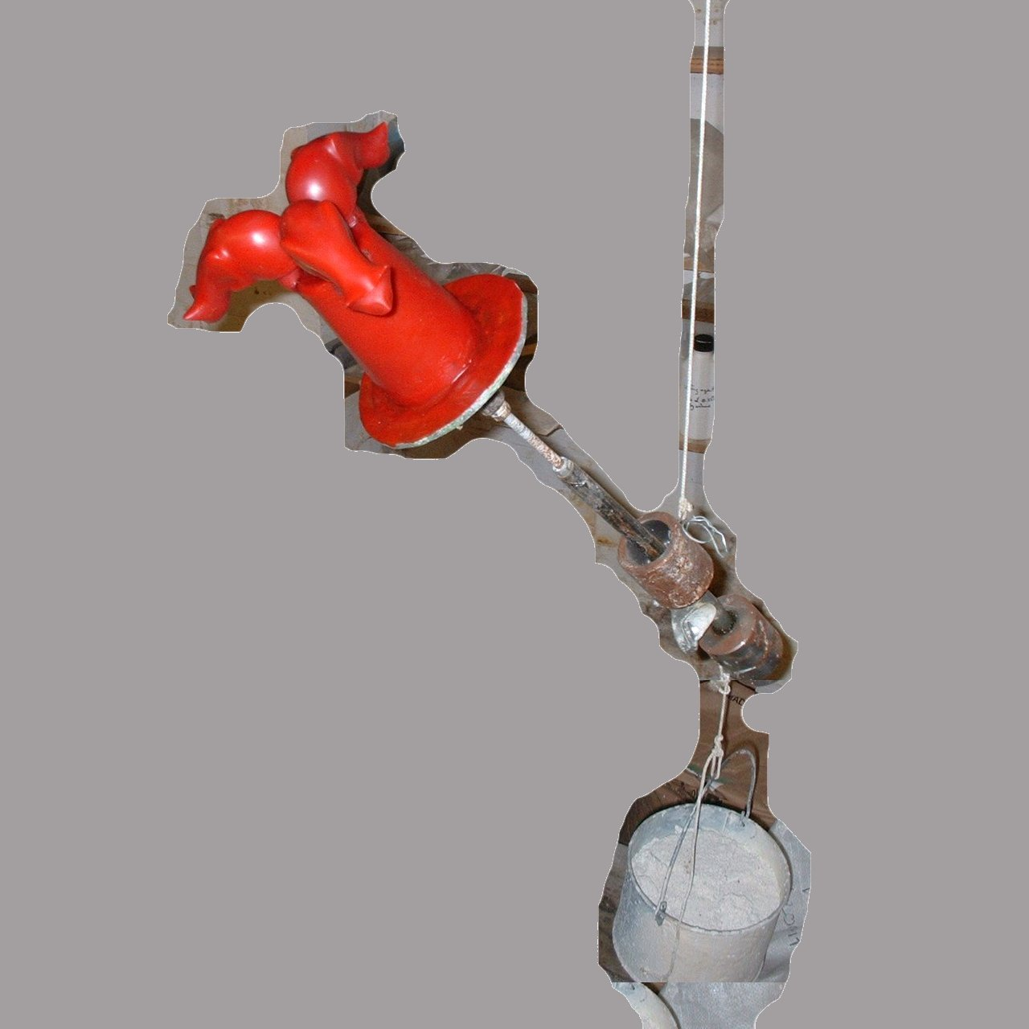

The viscosity of the slurry is set to 40 seconds using a Zahn cup #4. This has a 0.168 inch diameter hole in the bottom of an aluminium cigar tube cut down to be 2.685 cubic inches. The 40 seconds is the time from taking the cup out of the slurry until all drips have stopped.

After the first coat of slurry, drain until there is only a thin coating, and dust the surface using a hand with 60-80 sand, or molochite if obtainable, being careful to ensure that there are no bubbles on the model before the dusting. The sand is dry sieved from dried fine builders sand through a 60 mesh sieve using a hog hair brush [ac]. Only a single layer of 60-80 sand is used to avoid delamination after dewaxing, then place in a drying cabinet until dry. This takes about eight hours in a 1 cubic metre cabinet with six computer fans in the roof to circulate the air. Ensure that the cabinet in somewhere that has constant temperature and humidity, we use a cellar. The dusting is to make sure that the second coat of WexCoat slurry does not delaminate from the first coat, because delamination causes bits of WexCoat to be trapped within the body of the bronze.

The second coat of 30-80 molochite[u] is less critical so dipping can be used, but eight hours minimum should be allowed between every coat. If the WexCoat is not dry before wax burnout the ceramic shell will delaminate causing WexCoat inclusions below the surface of the model which makes it unusable, i.e. will spoil the casting. The third coat of slurry with 16-30 Molochite [v] again dusted on by hand.

At this point if you wish to core the inside of the wax, follow the instructions in section 9, if you do not need to core the model the skip to section 10.

9. Traditional Plaster Core

  - Dry mix by weight 20% hard plaster, 52% 80 molochite and 28% 200 molochite to the required volume (overestimate the required volume since pouring something dry into cavity will leave bits sticking to inside of wax that could be knocked off by molten bronze and cause inclusions).
  - Measure and cut a number of threaded rods (M6 for small castings M8 for larger) and place them in the cavity where the core is to go, the stubs of the threaded rods should stick about 5mm above where the final surface of the core will be. The steel also transmits heat to the centre of core and aids cooking. Do not use less than M6 diameter as the core attacks the rod in the firing and will cause a loose core and failed cast.
  - Add water to dry mix until it is the consistency of easy pouring slurry.
  - Pour into cavity quickly as it sets within 8 minutes.
  - Leave in well-ventilated place for 24 hours to dry.
  - Note 1: The ceramic shell process can start after the shell has dried, remembering to completely cover the stubs of all the threaded rods.
  - Note2: Note that the 16 molochite tends to settle out very quickly, so if the orifice into which the core is to be poured is less than 1cm in diameter, replace the 16 molochite with 80 molochite.

10. Slurry.
There are four further coats of slurry WexCoat with 16-30 Molochite [v] dusted by hand, followed with a final coat of plain WexCoat slurry to seal the stucco grains and make cracks after dewaxing easier to see. This makes eight coats of slurry in total. The bigger the piece, the thicker the shell needs to be. Only the inside of the funnel is not coated, and the funnel's flat top serves as the base upon which the piece stands in the drying cabinet during this process. If any WexCoat gets inside the funnel take great care that the piece is not upended after the flash de-waxing until these pieces of dried WexCoat have been removed since if they get inside the shell they will spoil the casting.

11. Removal of aluminium plate
After coating with eight WexCoat coats putting the whole assembly onto a gas ring again, and inserting a knife between the aluminium and base of the WexCoat just after the wax has melted makes it easy to remove the plate. The M6 shaft can be unscrewed from the washer (which is left in and drops out during dewax) by locking two M6 nuts together on the shaft and then fitting a ring spanner over both nuts.

12. Burnout. A cupola style furnace is used for both burn-out and bronze melting. It consists of a standard 55 gallon oil drum with the lid cut out, leaving the strengthening ring intact. A flue hole of 5 inch diameter is cut in the lid that has not been cut out, and a 2.5 inch mousehole cut just above the rim at the opposite (cut-out) end. Four lifting rings are attached to the top of the drum and a counterweight system allows the oil drum to be lifted about six feet in the air, using two wires to two pulleys at the highest point, so that the wires are not in the direct path of the flue exit gasses. The whole casting area can be covered with corrugated iron to ensure that if it starts raining during the casting the process can be completed safely, otherwise casting can only be done when there is no danger of rain. The drum is lined with ceramic fibre [e] Isofrax is preferred, held in place with nichrome wire [f]. The furnace is heated with propane:- two 47Kg cylinders [g], and a venturi burner [h]. The end of the burner should be about 4-5 inches away from the mousehole, so that the flame drags enough extra oxygen into the furnace to ensure complete combustion of the propane, under the correct conditions it takes about 45 minutes to get the furnace and crucible up to 1120 deg C. The furnace sits on a bed of insulating high temperature B26 firebricks [i]. These firebricks should be covered with a thin layer of dry builders sand, which should be checked before each firing, since any pieces of slag may stick to the funnel and subsequently fall into the funnel causing an inclusion. Temperatures are measured through a small hole in the oil drum using a pyrometer [j] and K type thermocouple [k]. The furnace volume is reduced by creating a dome of two layers of ceramic fibre with a five inch hole cut in them. The top of a UK metal dustbin makes a good former. The dome should be a force fit to the ceramic lining of the oil drum, and held in place with three loops of nichrome wire poked through two holes drilled in the oil drum and then twisted together inside the furnace.

The ceramic shell-coated piece is placed cup-down in the furnace inside a structure of firebricks with a roof made by a pottery batt, after it has been heated to 1110 deg C. The firebricks are made by cutting ordinary firebricks into three using a diamond attachment to a large anglegrinder. The hot batt is moved out of the way before the piece is placed using a glaze claw tong [w], and then the hot batt replaced. The cupola is then lowered and the wax burnt out. The furnace is then held at 1110 deg C for about 10 minutes to fire the shell. Now all that remains of the original artwork is the negative space, formerly occupied by the wax, inside the hardened ceramic shell. The feeder and vent tubes and cup are also hollow.

13. Testing. The ceramic shell is allowed to cool, and any thin pieces around the funnel are broken off whilst the shell funnel is still inverted. This is to prevent small particles of WexCoat getting inside the shell. Any cracks produced during the dewax are sealed using firecement [x].

14. Pouring. An A10 clay graphite crucible [l] is placed in the furnace charged with enough silicon bronze [m] by volume to fill the shells and funnels. Before placing the crucible the base firebricks should be covered with a thin layer of dry builders sand, which should be checked before each firing, since any pieces of slag may stick to the funnel and subsequently fall into the funnel causing an inclusion. Incidentally the clay graphite is slightly water absorbent, so never attempt to clean it by using water, because it will spall in the next firing. The shells are packed around the crucible and all heated to between about 1110 degrees C for large bronzes to 1150 deg C for small bronzes when using the Brookside Metal high spec bronze. We use 1075 deg C for the cheaper Special Plasters’ bronze (which melt at a slightly lower temperature and is preferred because it is cheaper) for bronzes of about 10 cubic cm. The shells are take out of the furnace and placed funnel-upwards on dried sand. The sand must be absolutely dry since if molten bronze splashes on wet sand an explosion occurs. The bronze filled crucible is lifted out with special tongs [n] and placed in a pouring ring [o] above the sand, and is then poured carefully into the shell within 60 seconds of the shells being removed. If the shell were not hot, the temperature difference would shatter it. The bronze-filled shells are allowed to cool. If long thin models they can be laid against two cold firebricks, ensuring the minimum contact between the hot shell and the cold firebrick in order to keep them in position during casting.

Safety equipment is essential at this phase. Thick boots, a polycarbonate face guard [r], and chrome leather apron [s] and leggings are required [t]. Hold breath when looking into the furnace as dangerous metal fumes are given off from the melt.

15. Release. The shell is hammered away using a club hammer and small steel chisel, releasing the rough bronze. Small pieces of shell in hard to get at crevices are removed using a dental pick [p]. The spruing, which are also faithfully recreated in metal, are cut off using a hacksaw lubricated with oil, to be reused in another casting.

16. Metal-chasing. Just as the wax copies were "chased," the bronze copies are worked until the telltale signs of casting are removed, and the sculptures again look like the original artwork. The stubs of spruing are filed down and polished. A Dremel Model 398 was used, this comes with a wide range of sanding and polishing tools, and has electronic speed control.

17.Patinating.
Before patinating the bronze is cleaned by sandblasting. We use a sandblast attachment [y] to an ordinary patio pressure washer. We use ordinary builder’s sand dried on a tray above a radiator, and sieved to remove any large grit. In use ensure the feed comes in from above the water jet to prevent blocking. If the sand blocks due to wet sand, flush the sand inlet of the attachment with water and allow to dry before using again.

The best book on patination is Patinas For Silicon Bronze - Kipper, Patrick V [1996]

{?The bronze is coloured to the artist's preference, using chemicals applied to heated or cooled metal. Using heat is probably the most predictable method, and allows the artist to have the most control over the process. This colouring is called patina, and is often green, black, white or brownish to simulate the surfaces of ancient bronze sculptures. (Ancient bronzes gained their patinas from oxidisation and other effects of being on Earth for many years.) Many recent U.S. artists prefer brighter, more stylised patinas. Patinas can replicate marble or stone. Depending on whether the metal is sandblasted or polished, the finish can be opaque or transparent. ?}

18 Sealing
After the patina is applied, and any residue washed off in clean water, a sealer is generally applied - traditionally a coating of wax, but sometimes lacquer over more unstable patinas. We use a 75/25 mixture of beeswax and Carauba wax [ad] heated to 100 deg C in a water bath, and applied to the bronze that has been preheated in an oven to about 150 deg C. This gives a thin layer of wax, since thick bits of wax cause fibres to be pulled out of the polishing pad. The bronze when cooled is then polished using a polishing kit mounted in an electric drill held in a vice. This helps protect the piece from ultraviolet rays, and can slow the discoloration of patinas by oxidation.

a)
http://www.tiranti.co.uk/subdivision_product_list.asp?Content=Type+B+Modelling+Wax+%2D+Waxes+%2D+Modelling+Materials&Subcategory=43&Subdivision=142
b)
http://www.tiranti.co.uk/subdivision_product_list.asp?Content=Green+Casting+Wax+%2D+Waxes+%2D+Modelling+Materials&Subcategory=43&Subdivision=140
c)
South Western Industrial Plasters, 63 Nether Street, Bromham, Chippenham, Wilts, SN15 2DP Tel 01380850616
d) http://www.specialplasters.co.uk/index.php?act=viewProd&productId=178
e) Ceramic Fibre - 1260ºC Body Soluble 96 Density (3.66m x 610mm
x 50mm roll) ISOFRAX
http://www.scarvapottery.com/opencontent/default.asp?itemid=413&section=PRODUCTS
f) http://www.scarvapottery.com/opencontent/default.asp?itemid=418&section=PRODUCTS
g)
Burner Kit 5 5-11 Cu Ft Kiln - 1 x N.100
http://www.scarvapottery.com/opencontent/default.asp?itemid=415&section=PRODUCTS
h)
http://www.flogas.co.uk/buy-online/gas-cylinders/47kg-propane-gas-cylinder-refill/
i)
High Temperature Insulating Bricks - B26 (230mm x 114mm x 76mm)
http://www.scarvapottery.com/opencontent/default.asp?itemid=413&section=PRODUCTS
j)
Pyrometer CA861
http://www.ttec.co.uk/shop/Chauvin_Arnoux_CA861/316.htm?jssCart=9f80190057971c2a79dc9e1b656e67f0
k)
K-type thermocouple TJ1-CAXL-IM60U-600-SMPW-M
http://www.omega.co.uk/ppt/pptsc.asp?ref=TJ36CAXL_NNXL&Nav=tema06
l)
http://specialplasters.co.uk/index.php?act=viewCat&catId=7
m)
Silicon Bronze to spec: Si 4-5%, Fe 0.5-1%, Mn 0.5-1%, Cu remainder
http://www.brooksidemetal.com/flash.html
Alternative cheaper Silicon Bronze
http://specialplasters.co.uk/index.php?act=viewProd&productId=46
n)
F6 Crucible Tongs for A10 crucible :K&M (Wholesale Suppliers) Ltd, Unit 24 Lion Park, Holbrook Industrial Estate, New Street, Halfway, Sheffield S20 3GH Tel 01142 474733
o)
F3 Ladle Handle (Pouring Ring) for A10 crucible :K&M (Wholesale Suppliers) Ltd, Unit 24 Lion Park, Holbrook Industrial Estate, New Street, Halfway, Sheffield S20 3GH Tel 01142 474733
p)
http://www.medema.co.uk/Dental_Surgical_Instruments~Dental_Surgical_Instruments_Probes_And_Explorers~3~102~0.htm
q)
Dremel Model 398 http://www.isaaclord.co.uk/products.aspx?subCat=513&parentCat=14/512/513
r)
Avenger Browguard Complete AVB/P200 :K&M (Wholesale Suppliers) Ltd, Unit 24 Lion Park, Holbrook Industrial Estate, New Street, Halfway, Sheffield S20 3GH Tel 01142 474733
s)
Pair Leggings (Chrome Leather) 14" :K&M (Wholesale Suppliers) Ltd, Unit 24 Lion Park, Holbrook Industrial Estate, New Street, Halfway, Sheffield S20 3GH Tel 01142 474733
t)
Apron Chrome Leather 36x24 :K&M (Wholesale Suppliers) Ltd, Unit 24 Lion Park, Holbrook Industrial Estate, New Street, Halfway, Sheffield S20 3GH Tel 01142 474733
u)
http://www.specialplasters.co.uk/index.php?act=viewProd&productId=181
v)
http://www.specialplasters.co.uk/index.php?act=viewProd&productId=179
w)
T1352 http://www.scarvapottery.com/opencontent/default.asp?itemid=430&section=PRODUCTS
x)
http://www.specialplasters.co.uk/index.php?act=viewProd&productId=217
y)
http://www.amazon.co.uk/Draper-65977-Pressure-Washer-Sandblasting/dp/B0006I2C4I/ref=sr_1_76?ie=UTF8&s=diy&qid=1224329305&sr=1-76
z) http://www.exmoorcastingsupplies.co.uk/casting-store.asp?catt=13
aa)Tiranti red wax
http://www.tiranti.co.uk/subdivision_product_list.asp?Content=Scopas+Red+Modelling+Wax+%2D+Waxes+%2D+Modelling+Materials&Subcategory=43&Subdivision=141
ab)Trisol 60 plus
http://www.blayson.com/downloads/T60_Usage_v1_1.pdf
ac) sieves
http://www.scarvapottery.com/opencontent/default.asp?itemid=471&section=PRODUCTS
ad)Carnauba Wax Flakes
http://www.axminster.co.uk/product-Liberon-Carnauba-Wax-21687.htm

